Muhammad Tanzil-ur-Rehman

BCS211037

Section 01

Lab 07

Walkthrough task 01

.model small

.data

str db 0ah,0dh,"$"

st db "\*$"

.code

mov ax,@data

mov ds,ax

mov cx,5

mov bx,cx

l2:

mov cx,6

l1:

lea dx,st

mov ah,09

int 21h

loop l1

lea dx,str

mov ah,09

int 21h

mov cx,bx

dec bx

loop l2

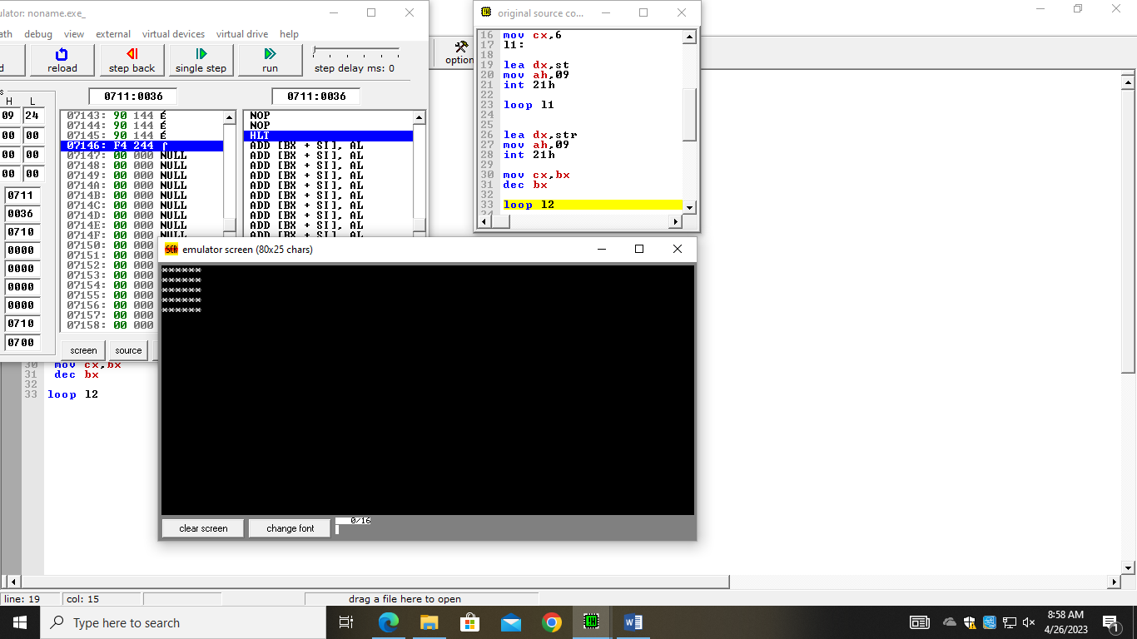

Walkthrough task 02

.model small

.data

str db 0ah,0dh,"$"

st db "\*$"

.code

mov ax,@data

mov ds,ax

mov cx,5

mov bx,cx

l2:

mov cx,bx

l1:

lea dx,st

mov ah,09

int 21h

loop l1

lea dx,str

mov ah,09

int 21h

mov cx,bx

dec bx

loop l2

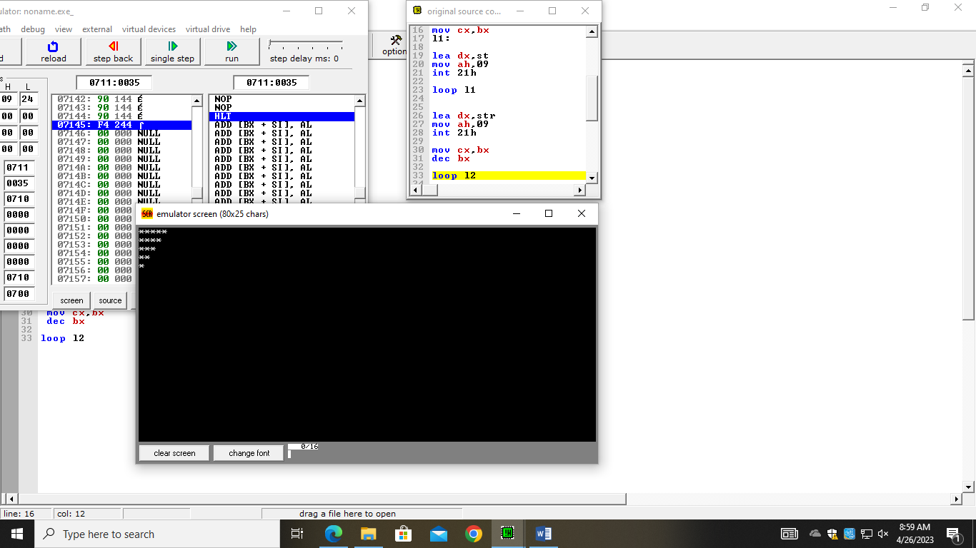

Task 01

.model small

.data

str db " $"

.code

mov ax,@data

mov ds,ax

mov cx,5

mov bx,cx

l2:

mov cx,5

mov dl,48

l1:

mov ah,02

int 21h

inc dl

loop l1

lea dx,str

mov ah,09

int 21h

mov cx,bx

dec bx

loop l2

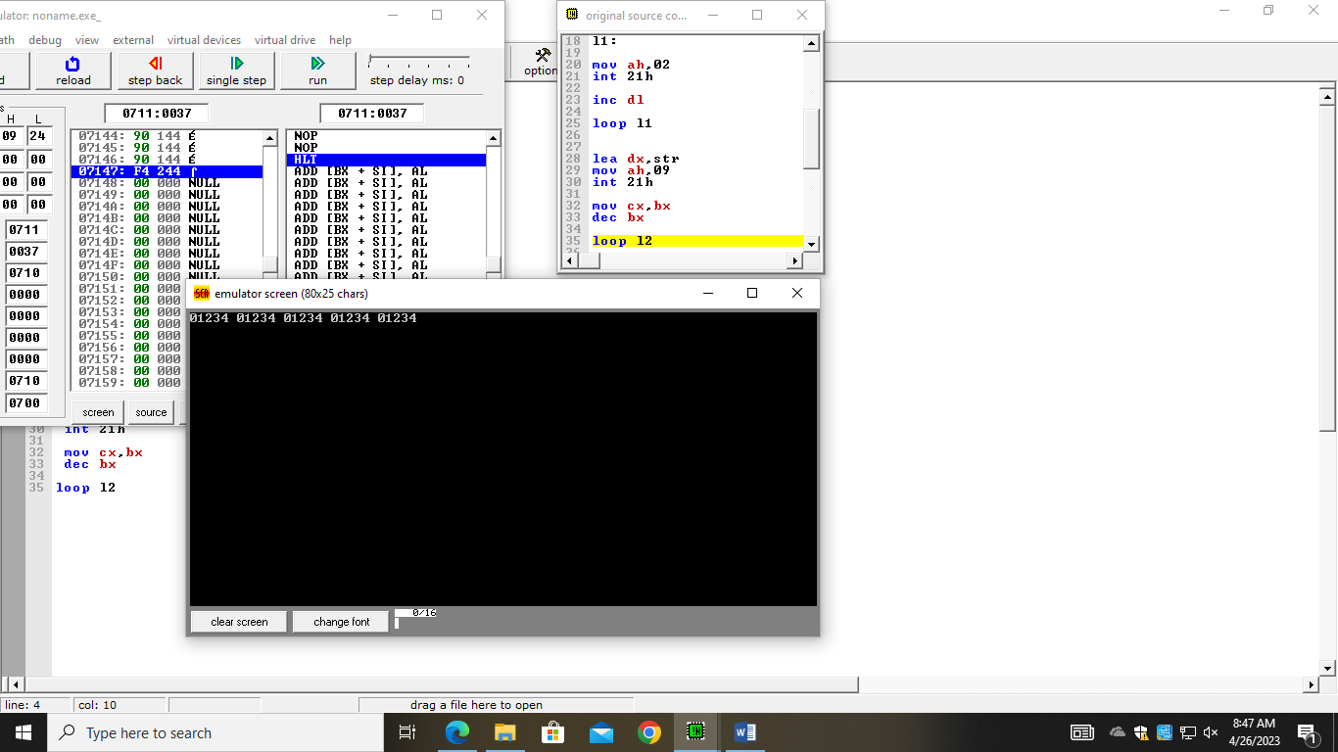

Task 02

.model small

.data

str db 0ah,0dh,"$"

.code

mov ax,@data

mov ds,ax

mov cx,5

mov bx,cx

l2:

mov cx,6

mov dl,0

l1:

mov ah,02

int 21h

inc dl

loop l1

lea dx,str

mov ah,09

int 21h

mov cx,bx

dec bx

loop l2

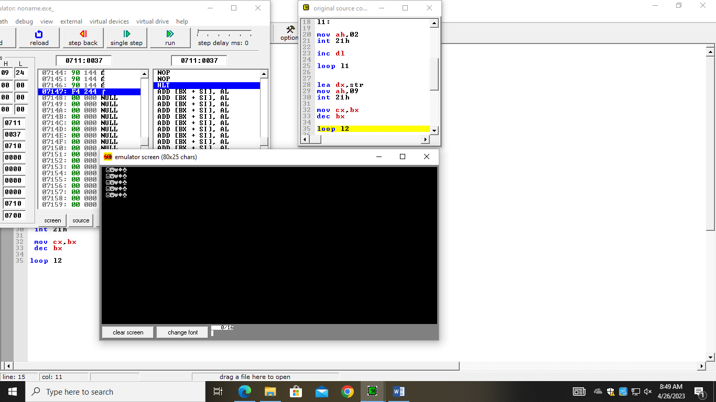

Task 03

.model small

.data

str db 0ah,0dh,"$"

.code

mov ax,@data

mov ds,ax

mov cx,5

mov bx,cx

l2:

mov cx,6

mov dl,48

l1:

mov ah,02

int 21h

inc dl

loop l1

lea dx,str

mov ah,09

int 21h

mov cx,bx

dec bx

loop l2

